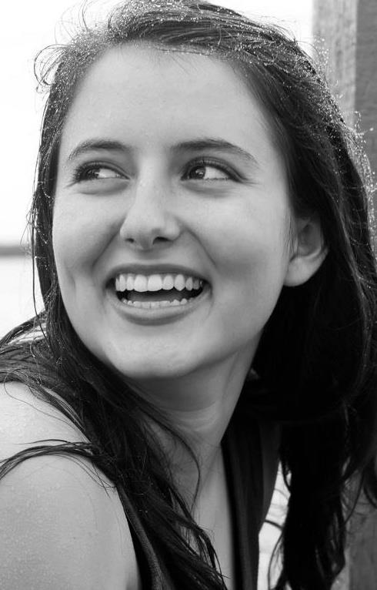
Tegwyth Alderson-Taber
Actor
2190 Tanglewood Way NE Height: 5’7”
St. Petersburg, FL 33702 Weight:150lbs.
727-481-9682 Hair: Brown
tegwythaldersontaber@gmail.com Eyes: Brown

THEATER
Dollinger Center for the Arts
Footloose Vi Moore Dir. Tara Quellhorst
Once Upon a Beginning Noah’s Wife Dir. Tara Quellhorst
All I…Learned in Kindergarten Principal Actor Dir. Tara Quellhorst
Beauty and the Beast Cogsworth Dir. Joel Rainey
You’re A Good Man Charlie Brown Snoopy Dir. Joel Rainey
Dartmouth Theater
Romeo and Juliet Sampson/Gregory Dir. Peter Hackett

LIVE PERFORMANCES
Dollinger Center for the Arts
Dance Showcases Dancer Dir. Krista Coker
Musical Theater Concert Ensemble Dir. Mike Davis

FILM/TELEVISION
Stories Growing Films
Method Acting Abby Dir. Hugh R. Sagona
VH1
Love and Hip Hop Background

TRAINING
Dartmouth College B.A. in Theater and Environmental Studies (’17)
Laura Edmondson, James Rice, Peter Hackett, Michael Cox, Laurie Churba
London Academy of Music and Dramatic Arts – Shakespeare Short Course (’16)
William Oldroyd, Dominic Rouse
American Stage Theater Co. – SPARK Original Teen Production (’11-’12)
Theatrical Vocal Training (’06-’13)
Mark Lubas, Dr. Leanna Valente
Judith Lee’s Dance School (’00-’10)
Judith Lee Johnson, Krista Coker
La Jolla Play House – Young Performers Workshop (’10)

Skills
Accents (English), Basic French, Cheerleading, Volleyball, Juggling, Soccer, Basic Gymnastics, Costume Design, Driver’s License, U.S. Passport, Alto, Improv Comedy, Bowling, Golf, Kayaking, Scuba Diving, Stage Combat, Business Background (Tuck Business Bridge Program)

Awards
Florida District 4 Best Supporting Actress - Noah’s Wife (‘13), Florida District 4 Critic’s Choice Ensemble Acting (’13), Florida District 4 Honorable Mention Monologue (’11,’12, ’13), Florida District 4 Superior Monologue (’11,’12,’13), Florida State Superior Monologue (’13), Dollinger Center for the Arts Best Supporting Actress - Cogsworth (’12)

